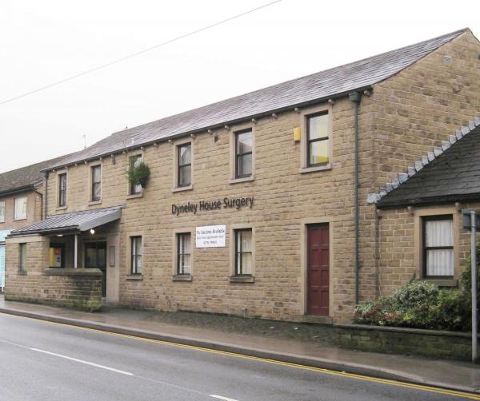

PATIENT PARTICIPATION GROUP

CONSTITUTION

February 2021
DYNELEY HOUSE SURGERY – PATIENT PARTICIPATION GROUP

TERMS OF REFERENCE
To obtain patients views on the quality and range of services provided by the Practice.
To facilitate a patient contribution to the development of new or extensions to services provided by the Practice.
To work in partnership with the Practice to influence the design, shape and provision of health and social care for the communities served by the Practice.
To review the results of the Practice’s anonymised patient surveys and, where appropriate, suggest changes in order to improve services.
To communicate, generally via the Practice, relevant information arising from the work of the Patient Group to the communities served by the Practice.
To liaise with the other Patient Group/s particularly in the Skipton locality.
MISSION STATEMENT
Act on behalf of Dyneley House’s patients to influence and communicate on the provision of health related services.
CONSTITUTION
NAME: The name of the group shall be THE DYNELEY HOUSE SURGERY PATIENT PARTICIPATION GROUP (The Group)
ASSOCIATION: The Group will be affiliated to the National Association for Patient Participation, (N.A.P.P).
OBJECTIVES: The objectives for which The Group is established, and aim to achieve by a process of continuous improvement are:
- To promote and protect the highest possible standards of medical and health care for the benefits of patients.
- To provide valuable, timely and balanced feedback to the Practice, representing patient views, to assist the Practice in accurately targeting services ( see communication below)
- To be a timely and effective communication channel from the Practice to the patients.

AIMS:
COMMUNICATION: Members of The Group should act as a communication channel between the Practice and the patients in order to help patients use facilities to the best advantage and the Practice to implement policies /services influenced by representative patient views. Towards this aim, the Group may from time to time conduct surveys in conjunction with the Practice.
HEALTH EDUCATION: The Group will endeavour to encourage a spirit of self help and support amongst patients and their families, by promotion of health education and awareness of topics deemed a priority and/or of value by both patients and Practice.
CHANGE MANAGEMENT: The Group will work with the Practice to ensure any key changes to the NHS/Practice/services are implemented with the support/input of the Group and with consideration to views obtained by the Group from a broad representation of the wider patient numbers. Communication of proposed and implemented changes will be a priority for the Group.
FUND RAISING: The Group has the option to raise funds for the benefit of the patients and Practice, but this is not the main focus/ role of the Group.
MEMBERSHIP: Membership shall be open and free to all patients and staff of the Practice. Membership of the Group will be terminated in the event of a member ceasing to be a patient of the Practice.
COMPLAINTS: The Group is not responsible for, indeed will not become involved in, the handling of complaints. The Practice has a separate procedure in place for such matters.
MEETINGS, COMMITTEE & OFFICERS: The Committee shall consist of up to fourteen members including a Chairman, vice Chairman, Secretary and Treasurer ( if appointed) Half the members shall retire annually and may be nominated for re-election at the Annual General Meeting (AGM) For transparency and in an advisory/ inform capacity, the Practice will be represented by a doctor, practice manager, nurse leader, and other staff as nominated by the Practice. The Practice members are not eligible to vote.
Should a member step down between each AGM a replacement member may be co-opted and will be eligible to vote on the committee.
The Committee shall endeavour to meet not less than six times in any period between two AGM’s, at such times as the Secretary shall specify as agreed by the Chairman.
All matters shall be determined by a majority of those present, in the event of a tied vote, the Chairman will have a second or casting vote.
Minutes of each meeting will be taken, kept and distributed to all Group members as well as being made available to all patients and practice staff.
The Committee shall be empowered to manage the affairs of the Group and to take any action on its behalf to further the aims of the Group.
At the meetings of the Committee, four members plus one officer shall constitute a quorum. The Committee may fill any casual vacancy occurring among its number until the AGM of the Group. The Committee may co-opt up to two people for specific purposes of the Committee or any sub- group. Co-opted members are not eligible to vote.
FINANCE: In the event that the Group raises funds, all such funds collected by the Group shall be handled to the Treasurer who shall pay the same into an account in the name of the Group at such bank or building society as Committee may from time to time decide. Any two Officers of the Committee must sign all cheques. Out of pocket expenses on behalf of the Group shall be claimed at any Committee meeting
Annual associate membership shall be paid to N.A.P.P. by the Practice.
Any out of pocket expenses incurred by the Group will be agreed and approved by the Practice manager.
ANNUAL GENERAL MEETING: An AGM shall be held annually in February, commencing 2012. A minimum of 28 days’ notice of the day, time and place shall be given via the notice boards, and Group Newsletter, Practice website. Nominations will also be requested.
Any nominations must be received a minimum of 7 days prior to the AGM and will require the agreement of the nominee and be seconded.
Items for the agenda shall be sent to the Secretary for consideration at least 7 days prior to the AGM date, and will be added subject to the agreement of the Committee.
ELECTION & RETIREMENT OF COMMITTEE MEMBERS. All Officers and Committee may offer themselves annually for re-election at the AGM. If more than one nomination is received for an Officer position then a vote must take place with a show of hands. In the event of a tie the Chairman has the casting vote.
REPORT & ACCOUNTS: The Committee shall present at each Annual General Meeting a report of the activities of the Group and its proceedings during the previous year, with a statement of accounts, if any, up to the end of the financial year on 31st January preceding the date of the AGM
ALTERATION TO THE CONSTITUTION: The Constitution may be rescinded or amended or waived by a resolution passed at an AGM or Special Meeting of which proper notice shall have been given to all members, by a 75% majority of the members present and voting. Provided that no alteration shall be made which would cause the Group to cease to be affiliated to NAPP.

February 2021

NOTE
This amended version was adopted at the Annual General Meeting held on Wednesday 24 February 2021

